Quarterly Management Report to the Executive Committee
January to March 2026
Air Quality Nexus Center

Submitted by: Air Quality Nexus Center (AirQC), Asian Institute of Technology
Submitted to: Board Executive Committee, Asian Institute of Technology
Submission date: April 10, 2026

About the center: The Air Quality Nexus Center (AirQC),established on June 1, 2024, envisions becoming a leading regional and international hub for application-driven research that delivers multiple benefits through reducing air pollution, improving human health, safeguarding ecosystems, and mitigating climate change. AirQC conducts high-quality, interdisciplinary research with real-life
applications, and capacity building to improve air quality in Asia and beyond.

A. Staff
- In-house Staff: (1) Prof. Nguyen Thi Kim Oanh (Director), (2) Dr. Lai Nguyen Huy (RS, Manager), (3) Ms. King Thwe Oo (RA), (4) Mr. Ha Quang Dang (RA), (5) Mr. Hun Win Thu (RA), (6) Mr. Taufik Rizki Ramadhan (RA)
- Research/Consultant: (1) Senior air quality expert (Thailand), (2) Senior air quality expert (Nepal), (3) Senior climate scientist (Germany), (4) Senior modeling expert (Indonesia), (5) Modeling expert (Vietnam), (6) Ph D student (Source Apportionment, Nepal), (7) GIS (Myanmar)

B. Research Projects
Continuing
- AQIP-Thailand: AFD-funded “Air Quality Improvement Program in Thailand”, 2023-2025 (Egis, AIT, AirParif, Citepa).
- CANBREATHE: Wellcome Trust funded “Climate Attribution of Wildfire Smoke Impacts on Priority Population Health in Southeast Asia and Australia (CANBREATHE)”, (Mar) 2025-2028. (Australia, Thailand, Indonesia, Cambodia, and Laos), Budget to Center: 400,000 AUD.
- Open Waste Burning Reduction Training Project (CCAC-Cambodia Project): CCAC-funded “Deliver training programme for implementing decrees for reducing open waste burning and air pollution”, 2025-2027. (CAA, AIT, MoE of Cambodia), Budget to Center: 70,825 USD

Closed Projects
- xxx.

New Projects
- Preparation of Memorandum of Understanding (MoU) between AIT and IRD: During the reporting period, AirQC supported the preparation of a Memorandum of Understanding between the Asian Institute of Technology (AIT) and the French National Research Institute for Sustainable Development (IRD) to establish a framework for cooperation in research, training, consultancy, and scientific exchange. The MoU emphasizes interdisciplinary collaboration on sustainable development, climate change and environmental sustainability, technological innovation, smart and resilient communities, and integrated food–energy–water systems.

C. Collaboration and outreach activities
1/ Networking and research collaboration
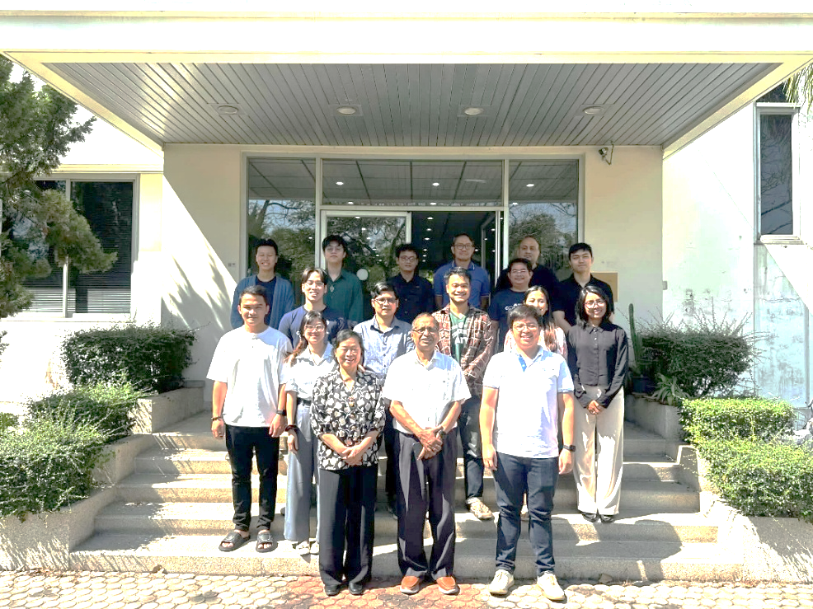
- Collaboration Meeting with Geoinformatics Center (GIC): On 23 January 2026, the AirQC team held a coordination meeting with the GIC team at the GIC meeting room to discuss ongoing activities and identify opportunities for collaboration. The discussion emphasized learning from the work of different centers to realize synergies and plan joint initiatives. The meeting also proposed organizing a joint seminar in January 2026, subject to availability, as a platform for knowledge exchange and collaboration planning.

Figure 1: Collaboration Meeting with GIC Team
- On 19 January 2026, the Air Quality Nexus Center (AirQC) held a networking meeting with Mr. Jesbin Baidya, Information Technology and Logistics Officer of the World Meteorological Organization (WMO), to discuss the IPCC SLCF LAM4 meeting and the potential organization of this meeting at the Asian Institute of Technology (AIT). During the meeting, the AirQC team provided an overview of AIT facilities and guided Mr. Baidya in reviewing the available venues and logistical arrangements to support the possible hosting of the meeting.
3/ Panelist/keynote/invited speaker at international and regional events
- From 11 to 13 March 2026, the Air Quality Nexus Center (AirQC) team participated in the Better Air Quality (BAQ) Conference 2026, held at the United Nations Conference Centre (UNCC) in Bangkok, Thailand. Organized by Clean Air Asia and partners, the conference brought together policymakers, researchers, development agencies, and practitioners from across the Asia-Pacific region to advance solutions for air pollution and climate challenges. Throughout the conference, AirQC researchers engaged in technical sessions, contributed to knowledge exchange, and supported discussions on regional air quality management. The BAQ 2026 Conference aimed to promote integrated and science-based approaches to address key air pollution sources, including transport, industry, energy, agriculture, and open burning, while emphasizing co-benefits for public health, climate mitigation, and sustainable development. The event also highlighted the importance of strengthened regional cooperation, policy alignment, and capacity building to tackle transboundary air pollution issues in Southeast Asia and beyond.
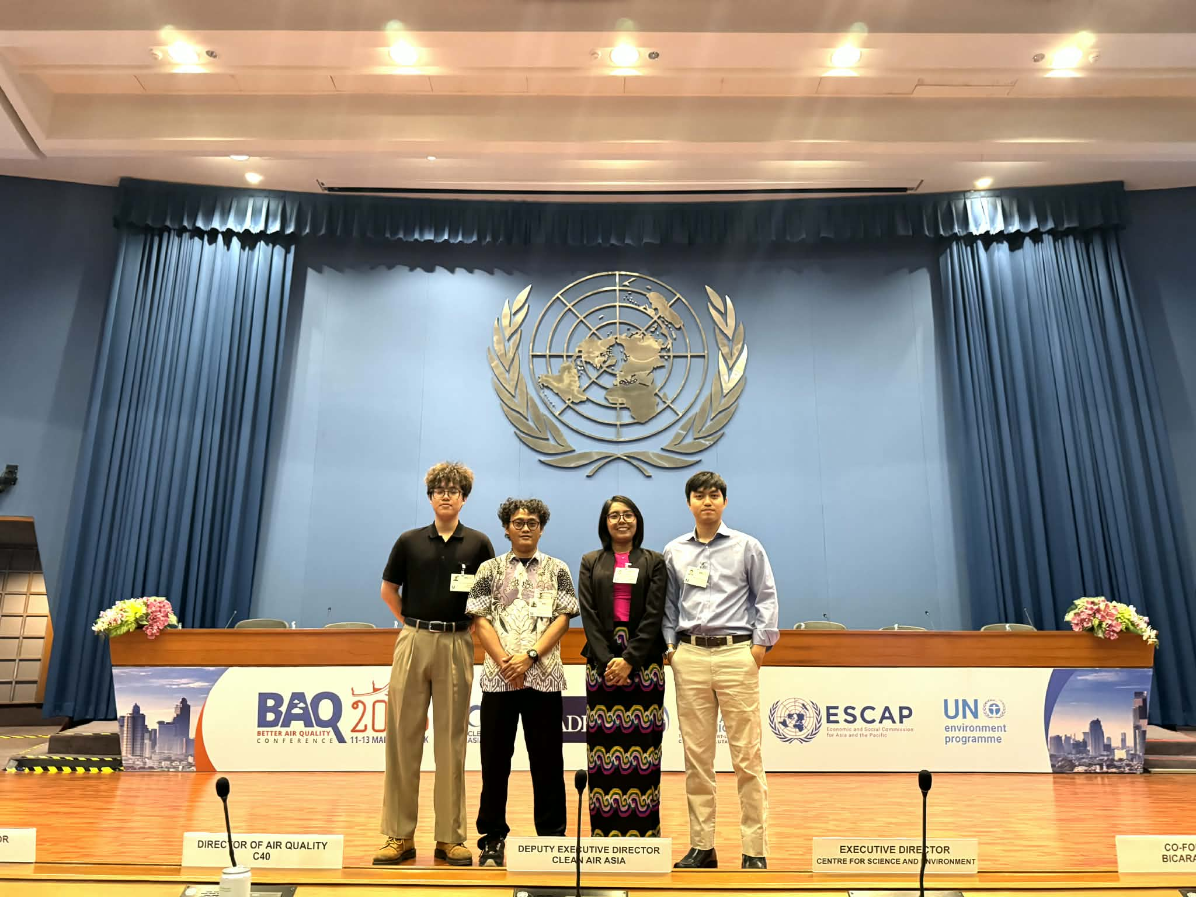
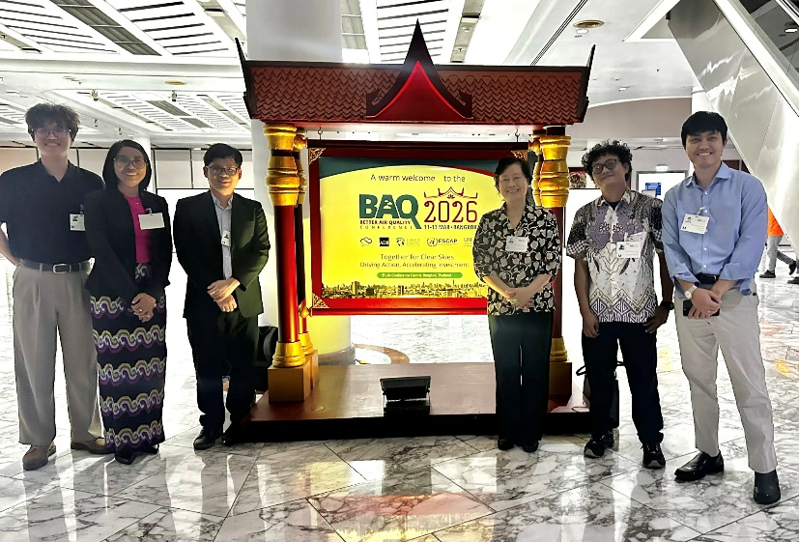
Figure 2 (a): Air Quality Nexus Center (AirQC) team participated in the Better Air Quality (BAQ) Conference 2026 (a)
Figure 2 (b): Air Quality Nexus Center (AirQC) team participated in the Better Air Quality (BAQ) Conference 2026 (b)
- In the session on “Strengthening Regional Cooperation to Manage Agricultural Open Burning and Wildfires in Southeast Asia and Beyond” held on 11 March 2026, Prof. Nguyen Thi Kim Oanh, Director of AirQC, delivered a presentation titled “Regional Overview of Agricultural Open Burning, Landscape Wildfires, PM2.5 & BC Pollution, and Transboundary Haze in Southeast Asia.” Her presentation provided a comprehensive overview of emission sources and regional pollution patterns, highlighting the contribution of open burning and wildfires to PM2.5 and black carbon (BC) levels, and emphasizing the need for coordinated regional actions, data sharing, and airshed-based management strategies to effectively address transboundary haze. For more information about the BAQ Conference 2026, please visit: https://cleanairasia.org/baq
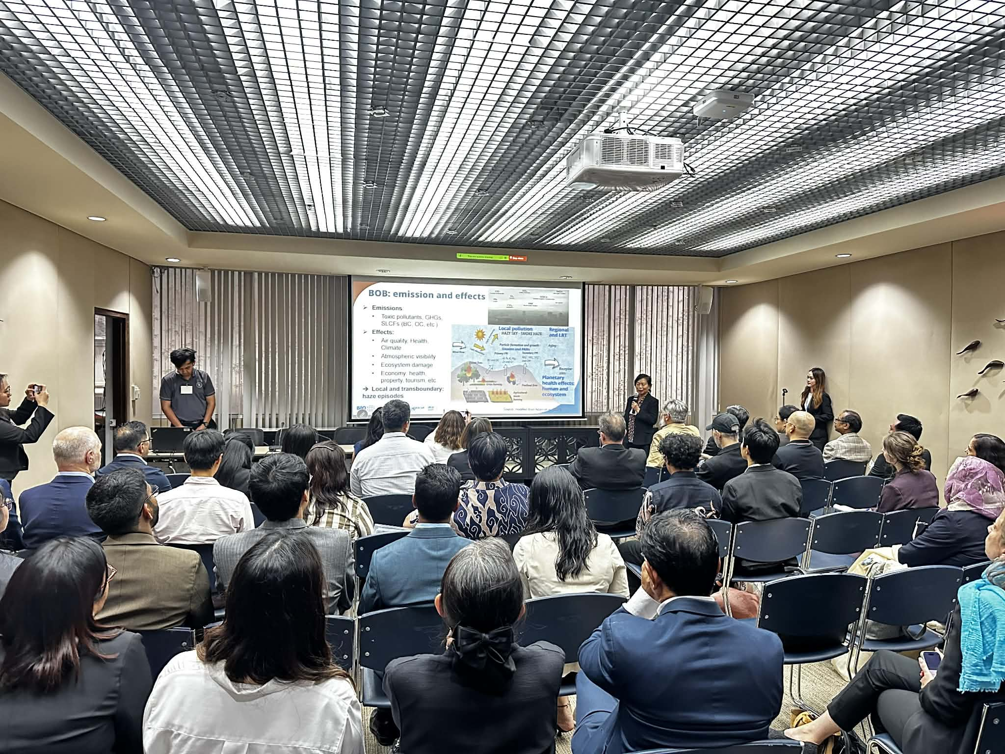
Figure 3: Prof. Nguyen Thi Kim Oanh, Director of AirQC, delivered a presentation at the Better Air Quality (BAQ) Conference 2026
- On 20 February 2026, the Air Quality Nexus Center (AirQC) participated in the Air Quality Management Lecture (AQML), a collaborative lecture series jointly organized by the Indian Institute of Technology Madras (IITM), the Air Quality Management Association (AQMA), the GCRF-Clean Environment and Planetary Health in Asia (CEPHA) Network, and the Indian International Conference on Air Quality Management (IICAQM). The lecture featured Dr. Javier Gonzalez-Rocha, Assistant Professor of Applied Mathematics at the University of California, Santa Cruz, who delivered a talk entitled “Sensing the Unseen: How Drones and Ground Sensors Reveal the Hidden Air Quality Impacts of Climate Change.” During the session, Prof. Nguyen Thi Kim Oanh (Center Director) and the AirQC team actively participated in the discussion, engaging with emerging approaches in air quality monitoring and their applications in addressing climate-related air pollution challenges.
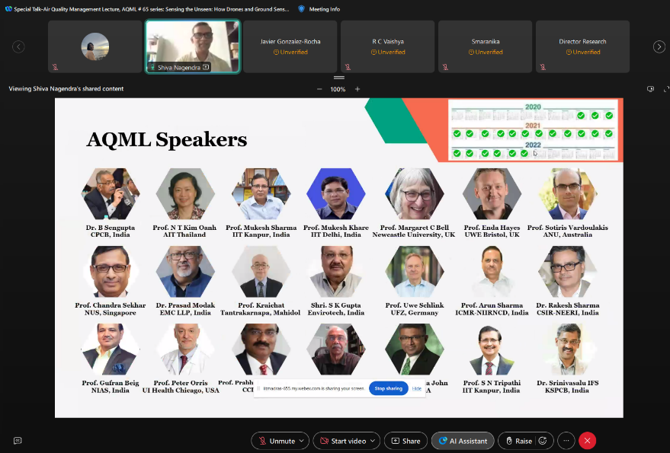

D. Organization of Conferences/Seminars/Workshops
- “CCAC-Cambodia Project Online Inception Meeting”: On 19 January 2026, the Air Quality Nexus Center (AirQC) participated in the online inception meeting of the CCAC-Cambodia project. During the meeting, Prof. Nguyen Thi Kim Oanh (Center Director) delivered a presentation entitled “International best practices on reducing open waste burning and air pollution,” providing an overview of proven policy approaches, regulatory measures, and implementation experiences relevant to supporting Cambodia’s efforts to reduce open waste burning and improve air quality.

F. Publications
- Okamoto, S.I., & Oanh, N.T.K. (2026). Statistics in Environmental Monitoring and Assessment (1st ed.). Chapman and Hall/CRC. https://doi.org/10.1201/9781003597216
- The Air Quality Nexus Center (AirQC) contributes to the Asian Institute of Technology’s efforts to map air pollution challenges across Southeast Asia by highlighting the often-overlooked impacts of waste-related air pollution. Across the region, nearly 15% of municipal waste is still burned in open piles, and field experiments conducted by AIT show that this practice releases approximately 482 nanograms of dioxins per kilogram of waste, resulting in an estimated 5.3 kilograms of highly toxic dioxins and 669,400 kilograms of cancer-linked chemicals emitted annually. These findings provide policymakers with clear scientific evidence of the serious health and environmental consequences of uncontrolled waste burning and reinforce the urgent need for sustainable waste management solutions. For more information, see the related video: https://www.eurekalert.org/multimedia/1110991

- 